Chapter 9 – Classes

Notes:

class Dog:

"""A simple attempt to model a dog."""

def __init__(self, name, age):

"""Initialize name and age attributes."""

self.name = name

self.age = age

def sit(self):

"""Simulate a dog sitting in response to a command."""

print(f"{self.name} is now sitting.")

def roll_over(self):

"""Simulate rolling over in response to a command."""

print(f"{self.name} rolled over!")

What does initialize mean? Initialize means set something up so it is ready to use

Examples outside Python:
- Initializing a phone → choosing language, Wi-Fi, account
- Initializing a car → turning the key so it’s ready to drive
- Initializing a character in a game → giving them a name, stats, gear

What does __init__ specifically do?
__init__ is the setup step for a new object

When you create a dog: my_dog = Dog(“Buddy”, 3)
Python does two things:
- Creates an empty Dog object
- Runs __init__() to fill it in

What does “empty object” mean?
Before __init__() runs, your dog exists… but knows nothing.

Think of it like this:
- The dog has been born
- But it doesn’t have a name or age yet

__init__() is where you teach the object who it is.

my_dog = Dog("Buddy", 3)

Python says:

“Okay, new Dog.

Run the setup instructions.

Your name is Buddy.

Your age is 3.

You’re ready.”

1. Object-Oriented Programming (OOP)
- OOP is a programming approach that models real-world objects.
- You write classes (blueprints) and create objects/instances from them.
- Classes define:
  - Attributes (data)
  - Methods (behaviors)
- Benefits:
  - Models real-world situations well
  - Makes code reusable and organized
  - Easier collaboration with other programmers
  - Encourages logical, high-level thinking

2. Classes and Objects
- Class: A blueprint that defines properties and behaviors.
- Object (Instance): A specific realization of a class.
- Instantiation: Creating an object from a class.

3. Creating a Class (Example: Dog)
You can model almost anything using classes. Let’s start by writing a simple class, Dog, that represents a dog, not one dog in particular, but any dog. What do we know about most pet dogs? Well, they all have a name and age. We also know that most dogs sit and roll over. Those two pieces of information (name and age) and those two behaviors (sit and roll over) will go in our Dog class because they’re common to most dogs. This class will tell Python how to make an object representing a dog. After our class is written, we’ll use it to make individual instances, each of which represents one specific dog.

- Class names use CamelCase.

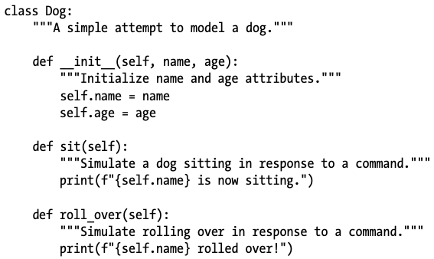

Key Components
- __init__() method:
  - Runs automatically when a new object is created
  - Initializes attributes
  - Uses self to refer to the current instance
- Attributes:
  - Variables prefixed with self
  - Accessible across all methods in the class

4. The self Parameter
- Refers to the current instance of the class
- Automatically passed when calling methods
- Required as the first parameter in all instance methods

5. Making an Instance
Think of a class as a set of instructions for how to make an instance. The class Dog is a set of instructions that tells Python how to make individual instances representing specific dogs.

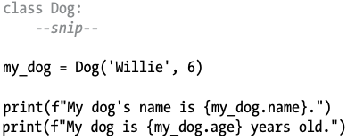

- Python:
  - Calls __init__()
  - Assigns attribute values
  - Returns a new instance

6. Accessing Attributes
- Use dot notation:
- my_dog.name
- my_dog.age

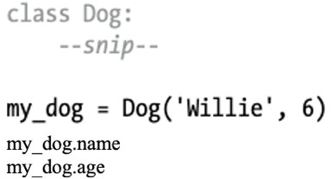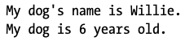

7. Calling Methods
- Use dot notation:
- my_dog.sit()
- my_dog.roll_over()
- Python finds and runs the method defined in the class.

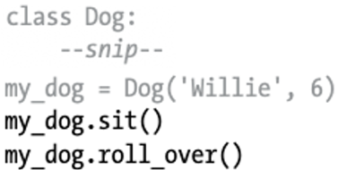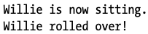

8. Multiple Instances
- You can create many objects from one class.
- Each instance:
  - Has its own attribute values
  - Shares the same methods
- Instances are independent of each other.

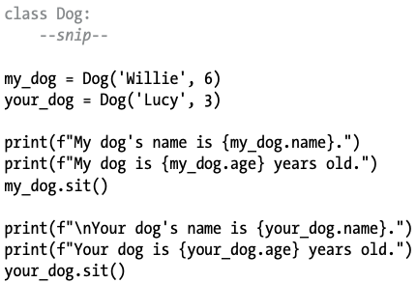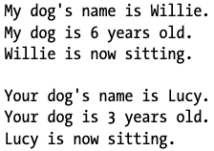

9. Working with Classes and Instances
You can use classes to represent many real-world situations. Once you write a class, you’ll spend most of your time working with instances created from that class. One of the first tasks you’ll want to do is modify the attributes associated with a particular instance.
- Attributes can be modified:
  - Directly
  - Through methods
  - By incrementing values

10. Example: Car Class
Let’s write a new class representing a car. Our class will store information about the kind of car we’re working with, and it will have a method that summarizes this information:

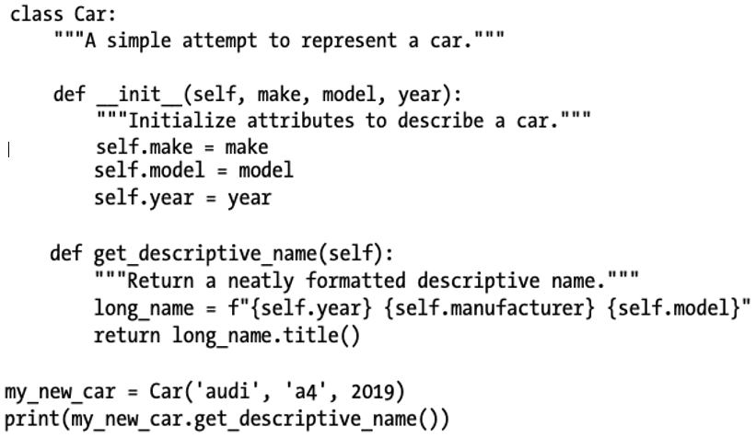

Setting a Default Value for an Attribute
When an instance is created, attributes can be defined without being passed in as parameters. These attributes can be defined in the __init__() method, where they are assigned a default value. Let’s add an attribute called odometer_reading that always starts with a value of 0. We’ll also add a method read_odometer() that helps us read each car’s odometer:

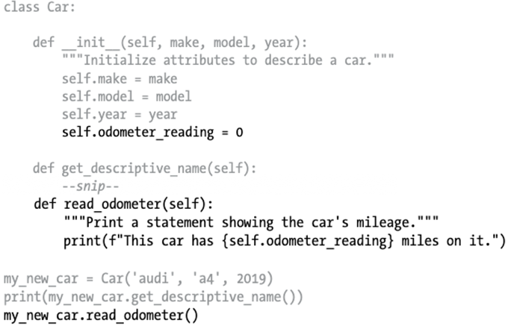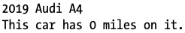

12. Modifying Attributes
Attributes can be modified: Directly, Through methods, By incrementing values

1. Direct Modification
The simplest way to modify the value of an attribute is to access the attribute directly through an instance. Here we set the odometer reading to 23 directly:

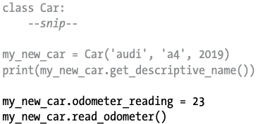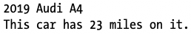

2. Using a Method

It can be helpful to have methods that update certain attributes for you. Instead of accessing the attribute directly, you pass the new value to a method that handles the updating internally.

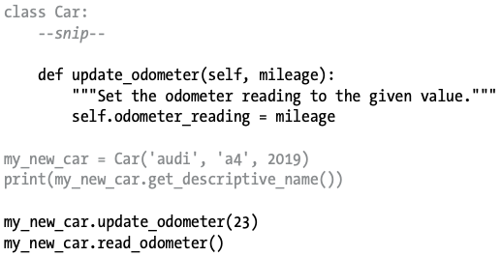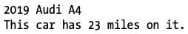

We can extend the method update_odometer() to do additional work every time the odometer reading is modified. Let’s add a little logic to make sure no one tries to roll back the odometer reading:

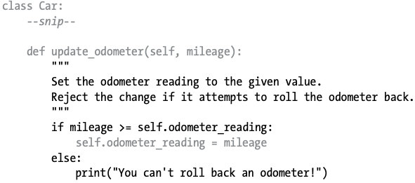

3. Incrementing

Sometimes you’ll want to increment an attribute’s value by a certain amount rather than set an entirely new value. Say we buy a used car and put 100 miles on it between the time we buy it and the time we register it. Here’s a method that allows us to pass this incremental amount and add that value to the odometer reading:

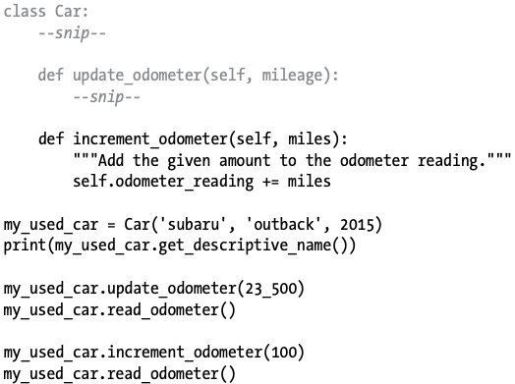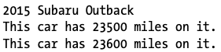

‘

13. Inheritance
You don’t always have to start from scratch when writing a class. If the class you’re writing is a specialized version of another class you wrote, you can use inheritance. When one class inherits from another, it takes on the attributes and methods of the first class. The original class is called the parent class, and the new class is the child class. The child class can inherit any or all of the attributes and methods of its parent class, but it’s also free to define new attributes and methods of its own.

14. Child Class __init__() and super()
When you’re writing a new class based on an existing class, you’ll often want to call the __init__() method from the parent class. This will initialize any attributes that were defined in the parent __init__() method and make them available in the child class.

As an example, let’s model an electric car. An electric car is just a specific kind of car, so we can base our new ElectricCar class on the Car class we wrote earlier. Then we’ll only have to write code for the attributes and behavior specific to electric cars.

Let’s start by making a simple version of the ElectricCar class, which does everything the Car class does:

- super() calls the parent class’s __init__() method.
- Ensures parent attributes are initialized.

We start with Car. When you create a child class, the parent class must be part of the current file and must appear before the child class in the file. We define the child class, ElectricCar. The name of the parent class must be included in parentheses in the definition of a child class. The __init__() method within the child class takes in the information required to make a Car instance.

The super() function is a special function that allows you to call a method from the parent class. This line tells Python to call the __init__() method from Car, which gives an ElectricCar instance all the attributes
defined in that method. The name super comes from a convention of calling the parent class a superclass and the child class a subclass.

We test whether inheritance is working properly by trying to create an electric car with the same kind of information we’d provide when making a regular car. We make an instance of the ElectricCar class and assign it to my_tesla. This line calls the __init__() method defined in ElectricCar, which in turn tells Python to call the __init__() method defined in the parent class Car. We provide the arguments 'tesla', 'model s', and 2019. Aside from __init__(), there are no attributes or methods yet that are particular to an electric car. At this point we’re just making sure the electric car has the appropriate Car behaviors:

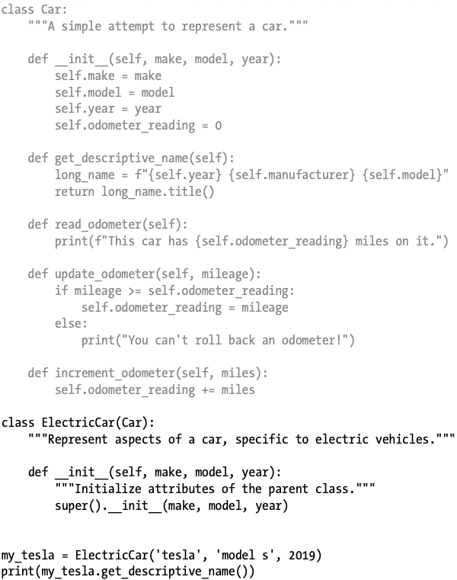

The ElectricCar instance works just like an instance of Car, so now we can begin defining attributes and methods specific to electric cars.
Defining Attributes and Methods for the Child Class
Once you have a child class that inherits from a parent class, you can add any new attributes and methods necessary to differentiate the child class from the parent class.
Let’s add an attribute that’s specific to electric cars (a battery, for example) and a method to report on this attribute. We’ll store the battery size and write a method that prints a description of the battery:

We added a new attribute self.battery_size and set its initial value to, say, 75. This attribute will be associated with all instances created from the ElectricCar class but won’t be associated with any instances of Car. We also added a method called describe_battery() that prints information about the battery. When we call this method, we get a description that is clearly specific to an electric car:

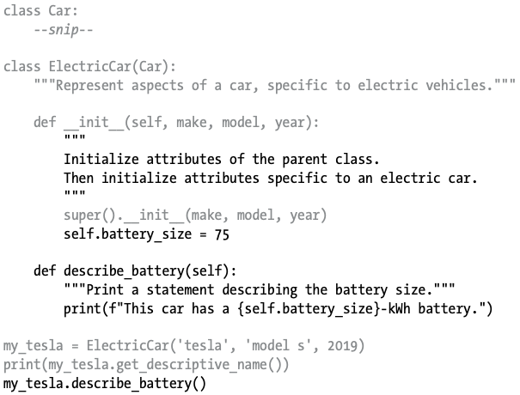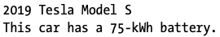

15. Overriding Methods
- Define a method in the child class with the same name.
- Python uses the child’s version instead of the parent’s.

You can override any method from the parent class that doesn’t fit what you’re trying to model with the child class. To do this, you define a method in the child class with the same name as the method you want to override in the parent class. Python will disregard the parent class method and only pay attention to the method you define in the child class. Say the class Car had a method called fill_gas_tank(). This method is meaningless for an all-electric vehicle, so you might want to override this method. Here’s one way to do that.

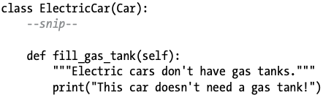

Now if someone tries to call fill_gas_tank() with an electric car, Python will ignore the method fill_gas_tank() in Car and run this code instead. When you use inheritance, you can make your child classes retain what you need and override anything you don’t need from the parent class.

16. Instances as Attributes
When modeling something from the real world in code, you may find that you’re adding more and more detail to a class. You’ll find that you have a growing list of attributes and methods and that your files are becoming lengthy. In these situations, you might recognize that part of one class can be written as a separate class. You can break your large class into smaller classes that work together.

For example, if we continue adding detail to the ElectricCar class, we might notice that we’re adding many attributes and methods specific to the car’s battery. When we see this happening, we can stop and move those attributes and methods to a separate class called Battery. Then we can use a Battery instance as an attribute in the ElectricCar class:

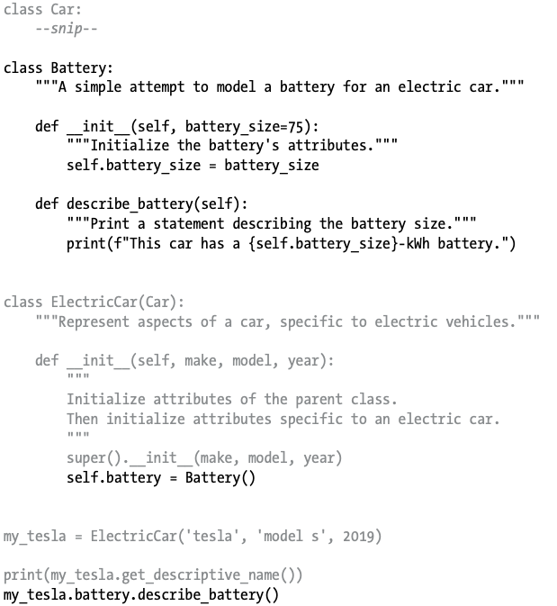
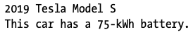

Within the class ElectricCar(Car), we created a new instance (object) from the Battery class.
self.battery = Battery()
my_tesla = ElectricCar(“tesla”, “model s”, 2019)
my_tesla.battery.describe_battery()
What we did was:
1) Create an object called my_tesla using ElectricCar class with following arguments
2) Create a Battery object and store a reference to it in my_tesla.battery
- describe battery size and describe the battery itself

Let’s add another method to Battery that reports the range of the car based on the battery size:

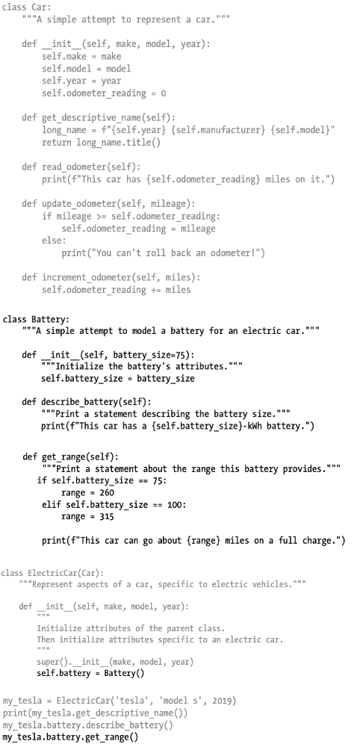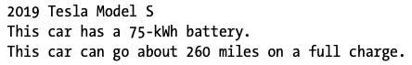

elif.thenwhat deep dive (Instances as Attributes) – Review morePractice.py

I have always wondered in the ElectricCar(Car) example why is Battery not included in the (). Car is a class and Battery is a class, so why is Battery not in ElectricCar(Car,Battery)

Multiple classes in the parenthesis – this is called multiple inheritance

ElectricCar(Car)
- Car is neither an argument or a definition
- Car is a base class (parent class/superclass)

Ex) class ElectricCar(Car, Battery):
pass
Syntactically possible, however conceptually wrong.
The reason it is a bad idea:
inheritance means “IS-A”
- An ElectricCar is a Car (YES)
- An ElectricCar is a Battery (NO)
composition means “HAS-A”

You define a class as an attribute if that class fits the has-a criteria.
The battery class is defined within the eletriccar class because electriccar has a battery (not is a battery)

17. Modeling Real-World Objects
- There is often no single correct design.
- Focus on:
  - Accuracy
  - Efficiency
  - Clarity
- Refactoring is normal and expected.

18. Importing Classes

Import a Single Class
from car import Car

Import Multiple Classes
from car import Car, ElectricCar

Import Entire Module
import car

Aliases
from electric_car import ElectricCar as EC

19. Modules
- Store related classes in a single file.
- Keeps programs clean and organized.
- Modules should include:
  - A module-level docstring
  - Related classes only

20. Importing Between Modules
- One module can import another if needed.
- Required when a class depends on another class.

21. Python Standard Library
- Built-in modules available in all Python installations.
- Example: random
  - randint(a, b) → random integer
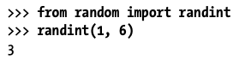
  - choice(sequence) → random element
  - 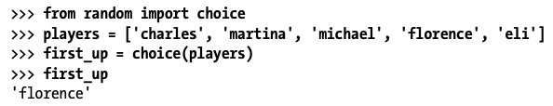
- Not suitable for security-related randomness.

22. Styling Classes (Python Conventions)
- Class names: CamelCase
- Instance & module names: lowercase_with_underscores
- Every class and module should have a docstring
- Use blank lines sparingly:
  - 1 line between methods
  - 2 lines between classes
- Import order:
  - Standard library
  - User-written modules

23. Chapter Summary
- Learned how to:
  - Create classes and instances
  - Use attributes and methods
  - Modify object data safely
  - Apply inheritance
  - Organize code using modules
  - Use Python’s standard library
  - Follow Python styling conventions

